Riccarton Cricket Club

Established 1905

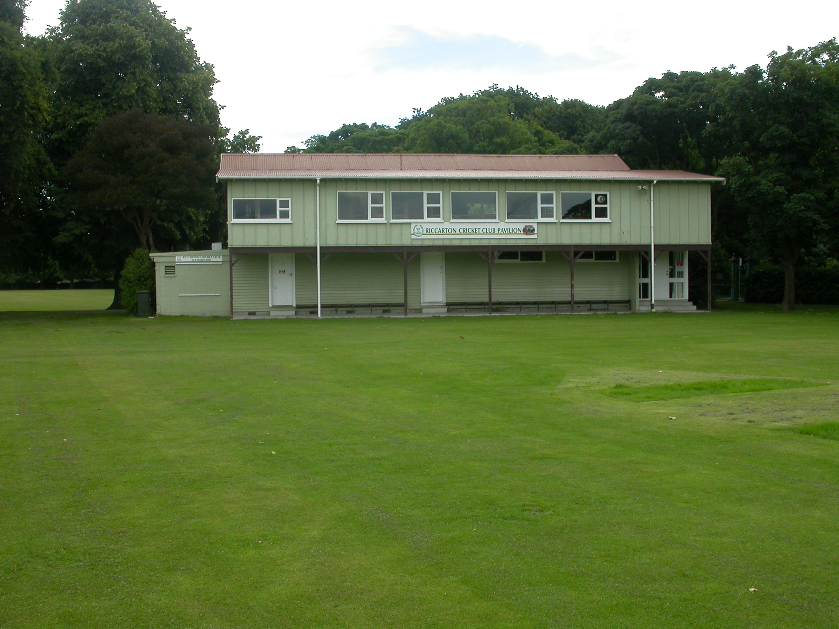

Home Ground Hagley Oval
Match pitches 2 grass match pitches
Practice pitches Grass block. artificial pitches on Polo ground

Entries 2001-02 8 men teams 2 women teams
2002-03 6 men teams 3 women teams 3 junior teams
2003-04 7 men teams 2 women teams 2 junior teams
2004-05 6 men teams 2 women teams 2 junior teams
2005-06 6 men teams 3 women teams 3 junior teams

Grade wins last 6 years
Men 2000-01 Sixth grade
2005-06 Third grade 1 day Fourth grade

Subscriptions Adult $225
Student $130
Junior

Income 2004/05 Subscriptions $13,130
Gaming $33,569
Total $54,405
Expenditure Grounds $7,247
Gear $2,333
Total $51,998
Surplus $2,407
Accumulated Funds $96,538

